Physical Activity and Fitness Puzzle
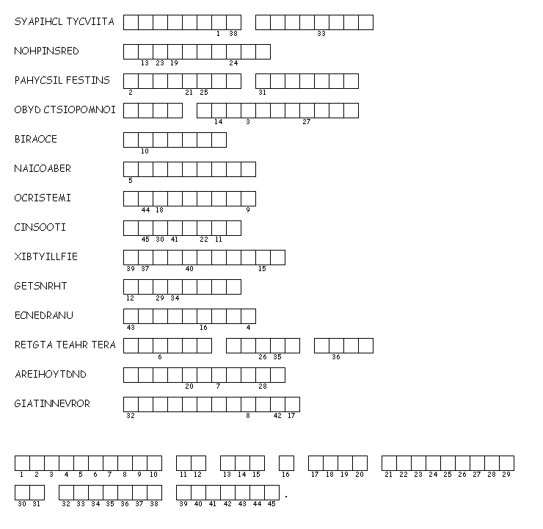
Unscramble each of the clue words.
Copy the letters in the numbered cells to other cells with the same number.
Created by Puzzlemaker at DiscoveryEducation.com

